
Lit from Within:
Developing Internal Motivation in the Gifted Student
Lisa Van Gemert, Gifted Youth Specialist, Mensa
Learn!  Mensa www.us.mensa.org  Foundation www.mensaforkids.org or  www.mensafoundation.org | Connect!  Keep up with the latest: giftedguru.com   @gifted_guru  facebook.com/giftedguru   pinterest.com/brightkids  linkedin.com/in/lisavangemert  Email me at LisaV@americanmensa.org or lisa@lisavangemert.com
Priority Take-Away:

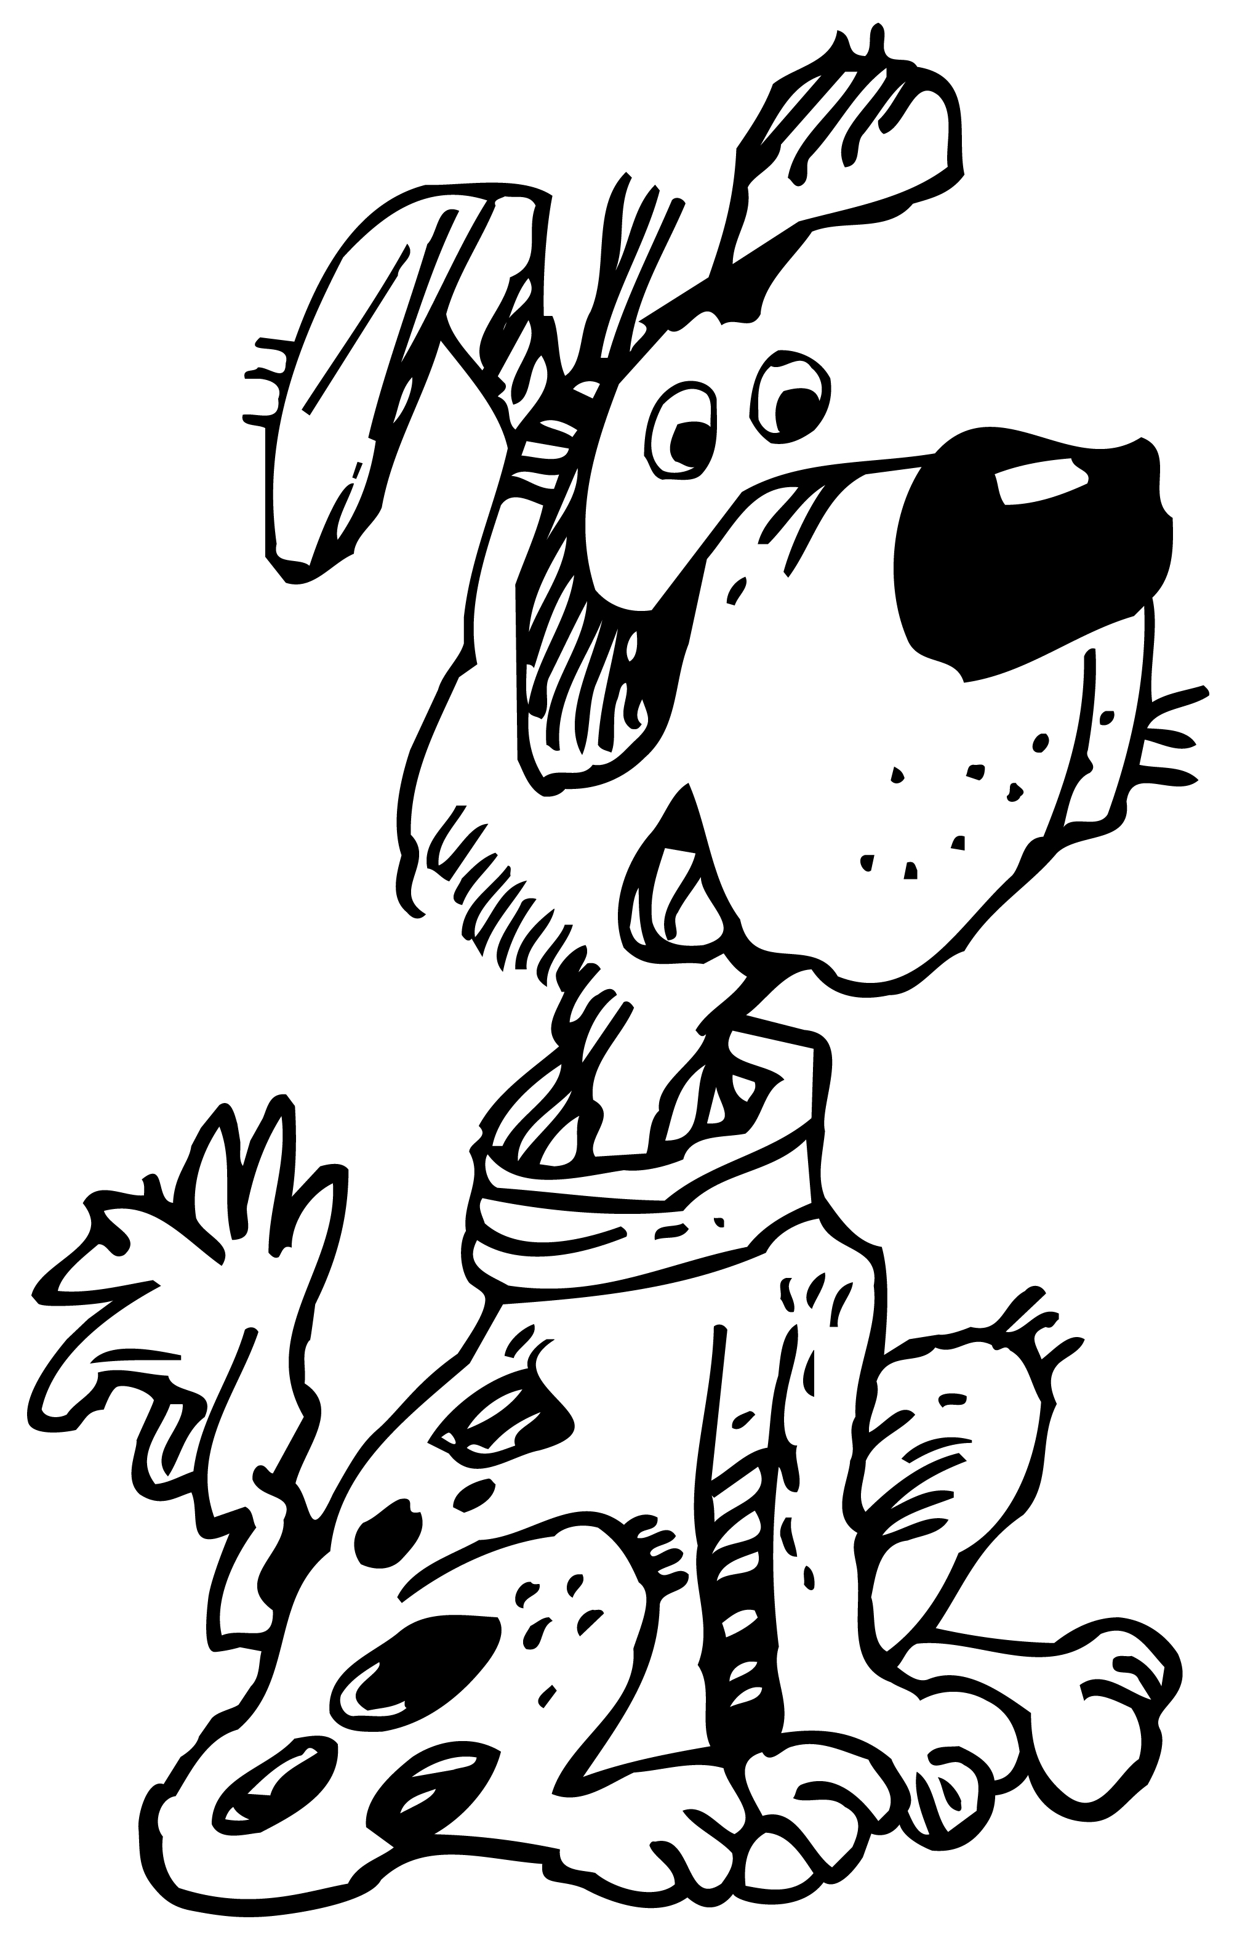
Motivation (Dan Pink, Drive: The Surprising Truth about What Motivates Us)
- – Maslow
- – Skinner
- – Internal Motivation
Rewards (learn more by reading Alfie Kohn, Punished by Rewards)
Problems:
- backfire
What’s wrong with these, anyway?
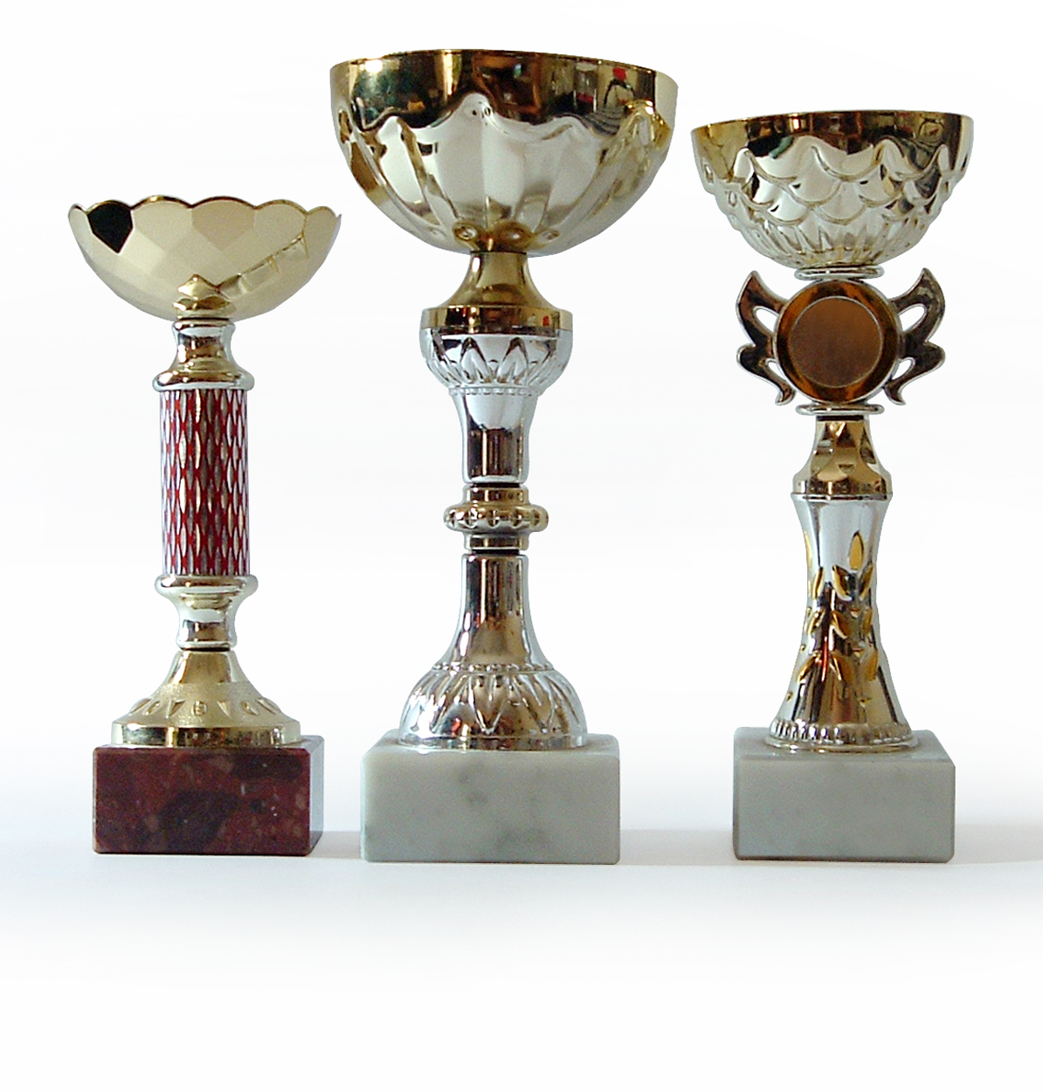
- narrow focus
- addictive
- drown out other voices
- change relationships
Solutions:
- put praise in its place (http://nymag.com/news/features/27840/ )

- Tom Sawyer the tasks

- embrace failure (John Maxwell, Failing Forward: Turning Mistakes into Stepping Stones for Success; K.M. Kostyal, Trial by Ice; Kim Heacox, Shackleton: the Antarctic Challenge)

- stress the vine

- appropriate challenge (Mihály Csíkszentmihályi, Flow and Edward L. Deci & Richard M. Ryan Motivation and Self-Determination in Human Behavior)

- know difference between obsession and motivation

What do we learn from them?

- allow boredom
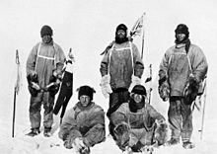
Stories:
- Fermat/Wiles

- Goodyear

- Scott (Ranulph Fiennes, Race to the Pole; Liz Gogerly, Amundsen and Scott’s Race to the South Pole)

The Trifecta
- Self-concept (Roy Baumeister, Rethinking Self-Esteem: Why Nonprofits Should Stop Pushing Self-Esteem and Start Endorsing Self-Control. (2005). Stanford Social Innovation Review.)

- Optimism/The Stockdale Complex (Jim Collins, Good to Great; Tali Sharot, The Optimism Bias: a Tour of the Irrationally Positive Brain)

- Grit [Angela Duckworth, Christopher Peterson, et al, Grit: Perseverance and Passion for Long-Term Goals. (2007) Journal of Personality and Social Psychology. 92(6), 1087-1101; K. Anders Ericsson, Ralf Krampe & Clemens Tesch-Romer, The Role of Deliberate Practice in the Acquisition of Expert Performance. (1993) Psychological Review, 100(3), 363-406.]

Take Aways:
  - grade school – continue to explore interest-based ideas
  - secondary – career/college-based interests (let that propel)
  - model finding other values in the task:
    - “I love the way I feel inside when I…”
    - “The house feels so much more welcoming when it’s clean. It’s a nice place to have friends over.”
    - “This isn’t my favorite thing to do, but I feel good about how I’m better at it than I was.”
  - Have a long-term goal yourself (language, skill, sport, instrument, craft)
  - Use quotations
  - Use the news to observe grit/optimism/self-concept
  - Help child set goals (objective-based)
  - Use rewards spontaneously, intermittently, and avoid peer pressure (adult)
Extend Your Learning:
- Josh Aronson, Improving Academic Achievement: Impact of Psychological Factors on Education
- Carol Dweck, Mindset and http://www.stanford.com/dept/psychology/cgi-bin/drupalm/system/files/Intelligence%2520Praise%2520Can%2520Undermine%2520Motivation%2520and%2520Performance.pdf

